Everyday Life Experiment: Elevators

Objectives:
- To explore pressure sensors in your digital devices and smartphones with the Phyphox Application
- To know what a barometer is
- To know what an accelerometer is
- To utilize a digital device like a smartphone to measure and graph displacement/height, velocity (vertical velocity), and acceleration of an elevator
- To learn and understand the motion graphs
- To easily observe the motion of the elevator in the graphs with Phyphox
- To understand and analyze the motion graphs and kinematics of the elevators: Height/Distance Travelled – Time Graph, Vertical Velocity – Time Graph, Acceleration – Time Graph
- To graph and export the data for the motion of an elevator with your smartphone easily and precisely
- To practice problem solving

First go to the Phyphox website and download the application on your device: https://phyphox.org/download/

To find more information on the Phyphox website about this experiment you may use this link: https://phyphox.org/experiment/elevator/

To watch the video of the Speed of an Elevator, use this link: https://youtu.be/y-goBtfuXAM
For reading Distance, Velocity, and Acceleration, use this link: https://phyphox.org/experiment/elevator/#more-503

In your device, follow the steps for running the Elevator experiment in Phyphox and doing the experiment.
- Choose Elevator under the Everyday life list menu. Place your phone on the floor of the elevator.

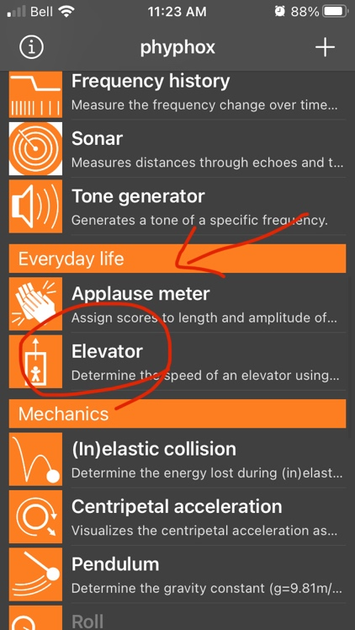

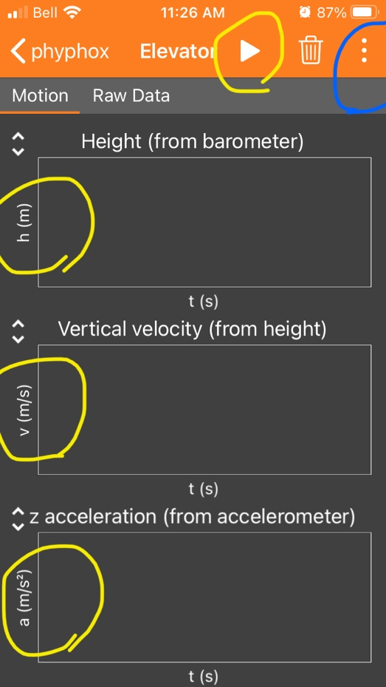
Yellow lines:
1-Play the application and graph the motions of the elevator.
2-Observe, measure and graph displacement, velocity, and acceleration of the elevator.
3-Export the data for further graphing (or using in other devices) and analyzing the elevator’s motion.

Blue Line:
1-Click on the three dots to see the option for exporting your data and enabling remote access on the device.
2-For exporting data, you have various option.

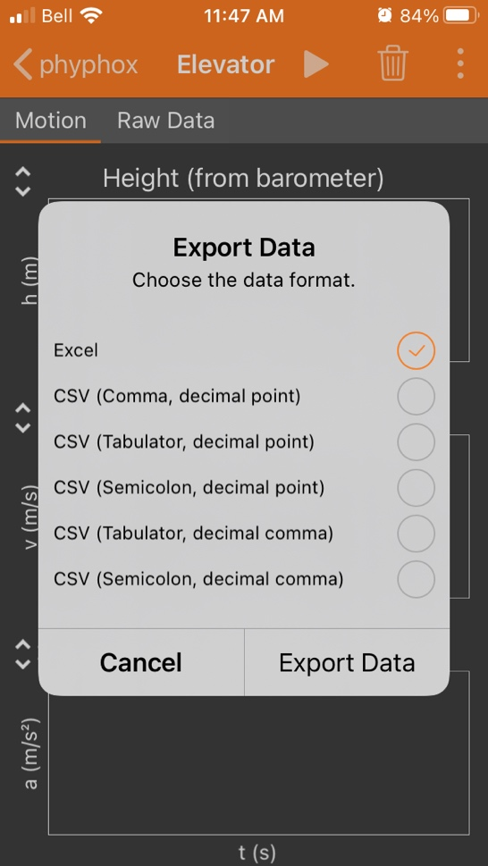

- Even you can create simple motion graphs with vertically moving your hand (up & down) and measure the height, vertical velocity, and acceleration of your hand.

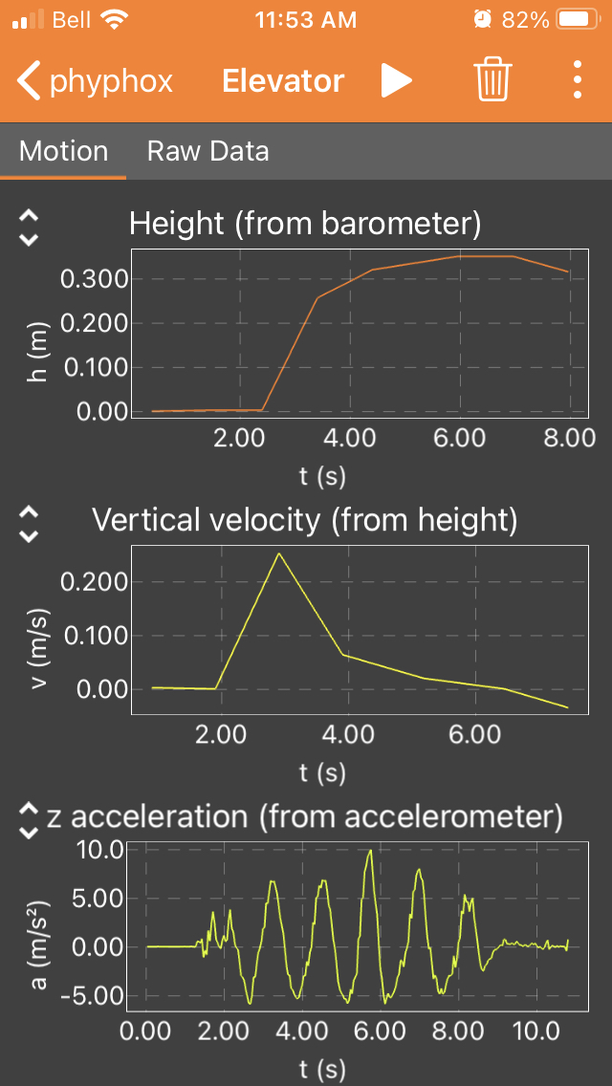

- Look at the following images from Phyphox and analyze the motion graphs and the movement of the elevator for the labelled parts: A, B, C, D, E, F, G, & H.

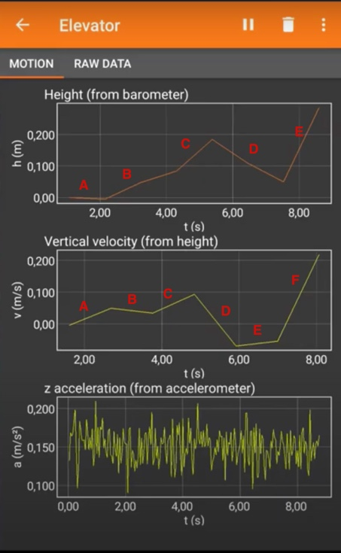

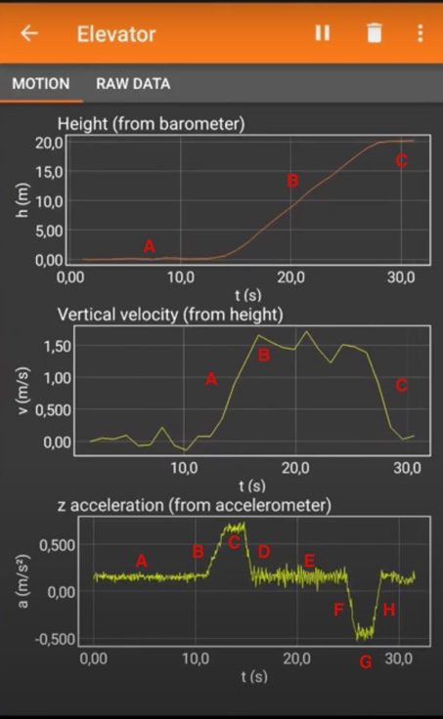

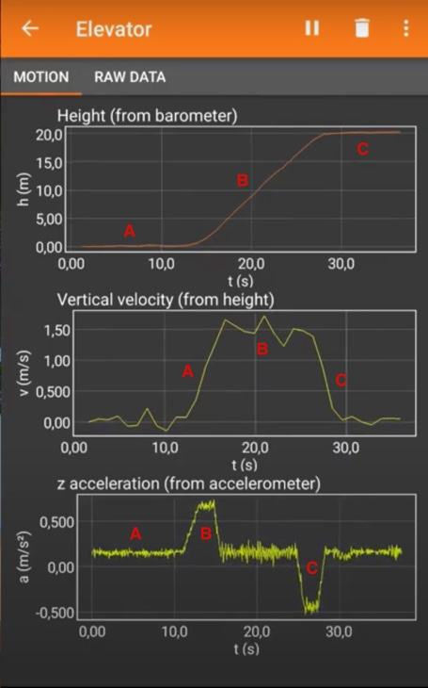

Notes:
You can get help from the graphs below:

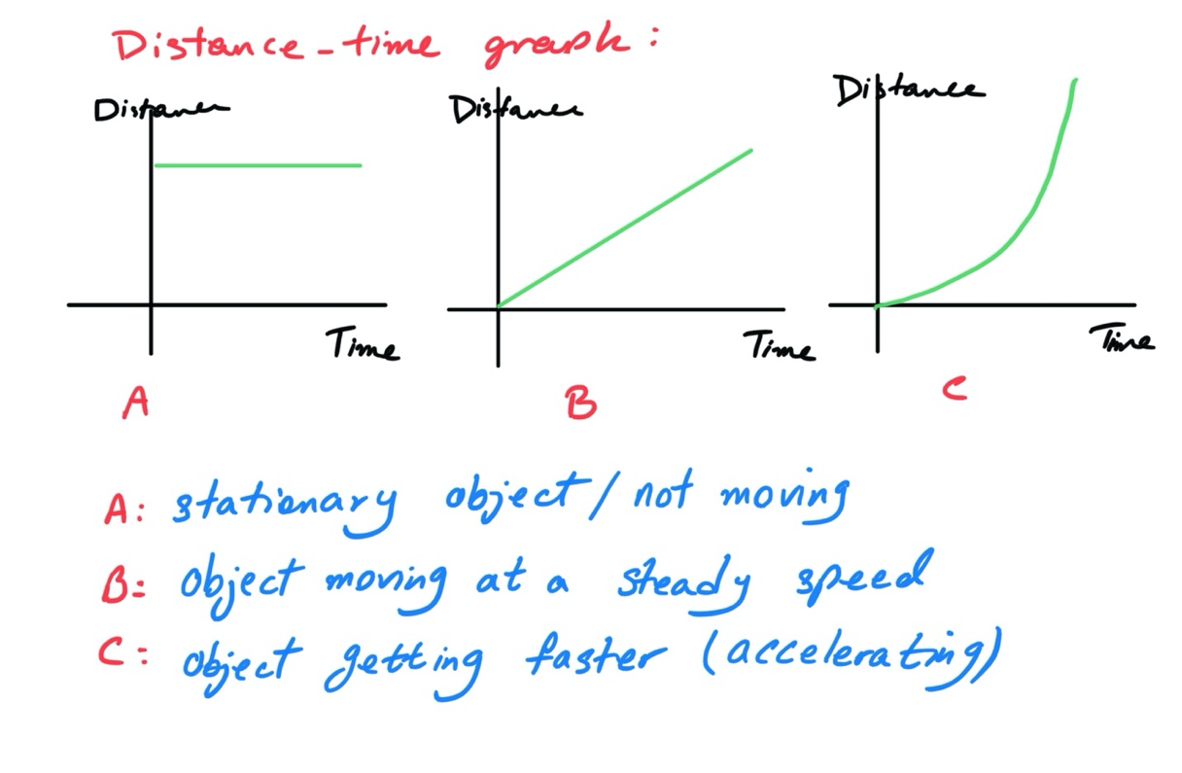
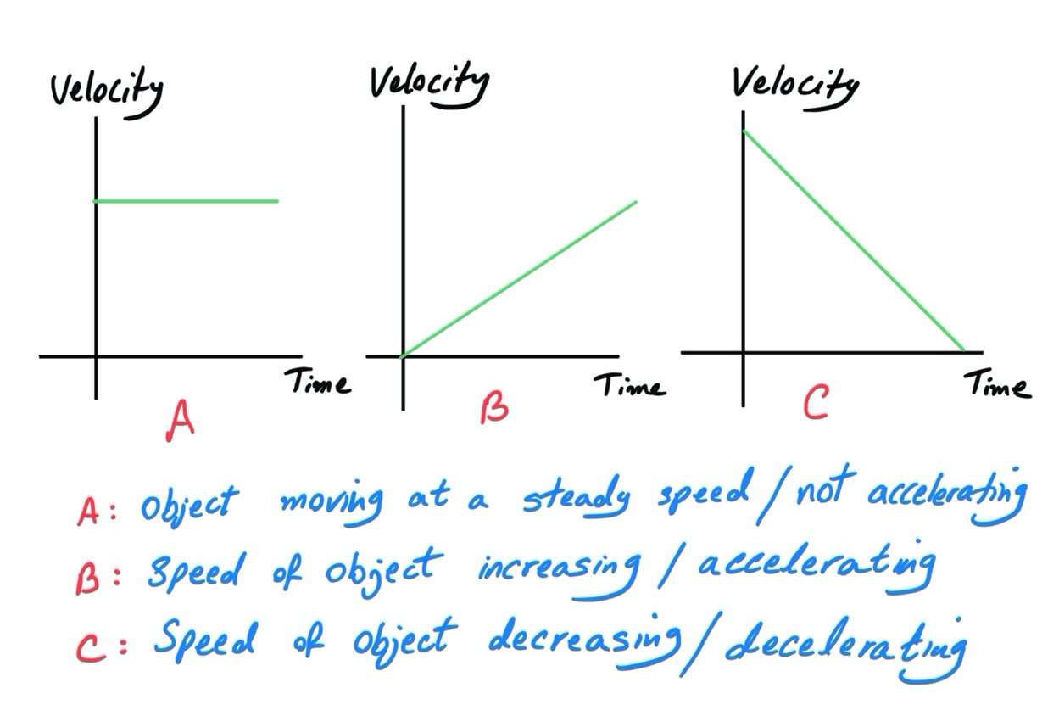

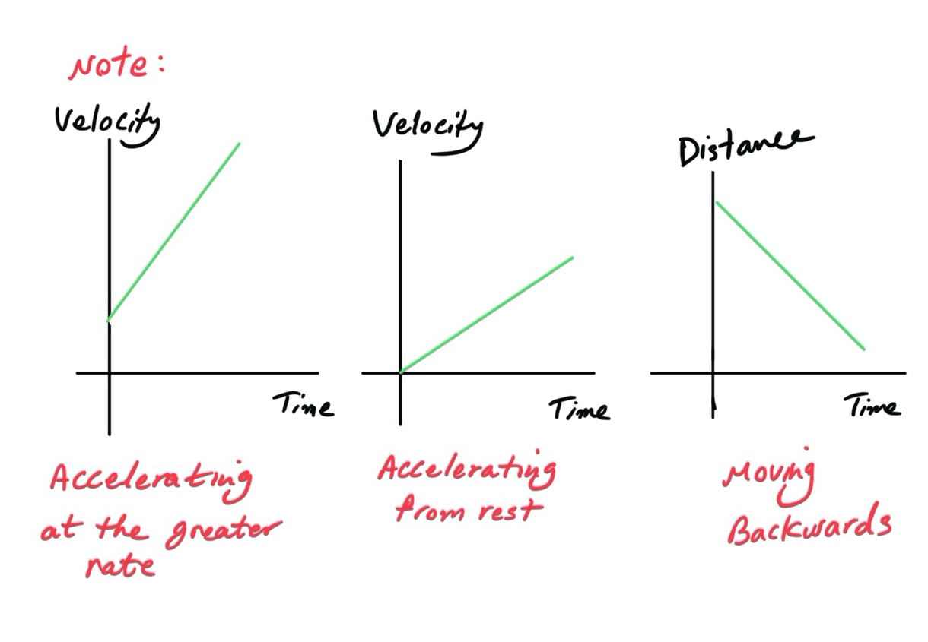
Conceptual Questions:

- What is a barometer?

- What is an accelerometer?

- A) Define Displacement, Velocity and Acceleration completely.
B) Are these scalar or vector quantities?
C) What is the difference between speed and velocity?
D) What are the SI Units of Displacement, Velocity and Acceleration?

- What is the difference between the gravitational mass and the inertial mass of an object?

Problem Solving:

- An elevator starts from rest on the ground floor and comes to rest at a higher floor.
We assume that the graph of the variation of the elevator’s velocity with time is like below.
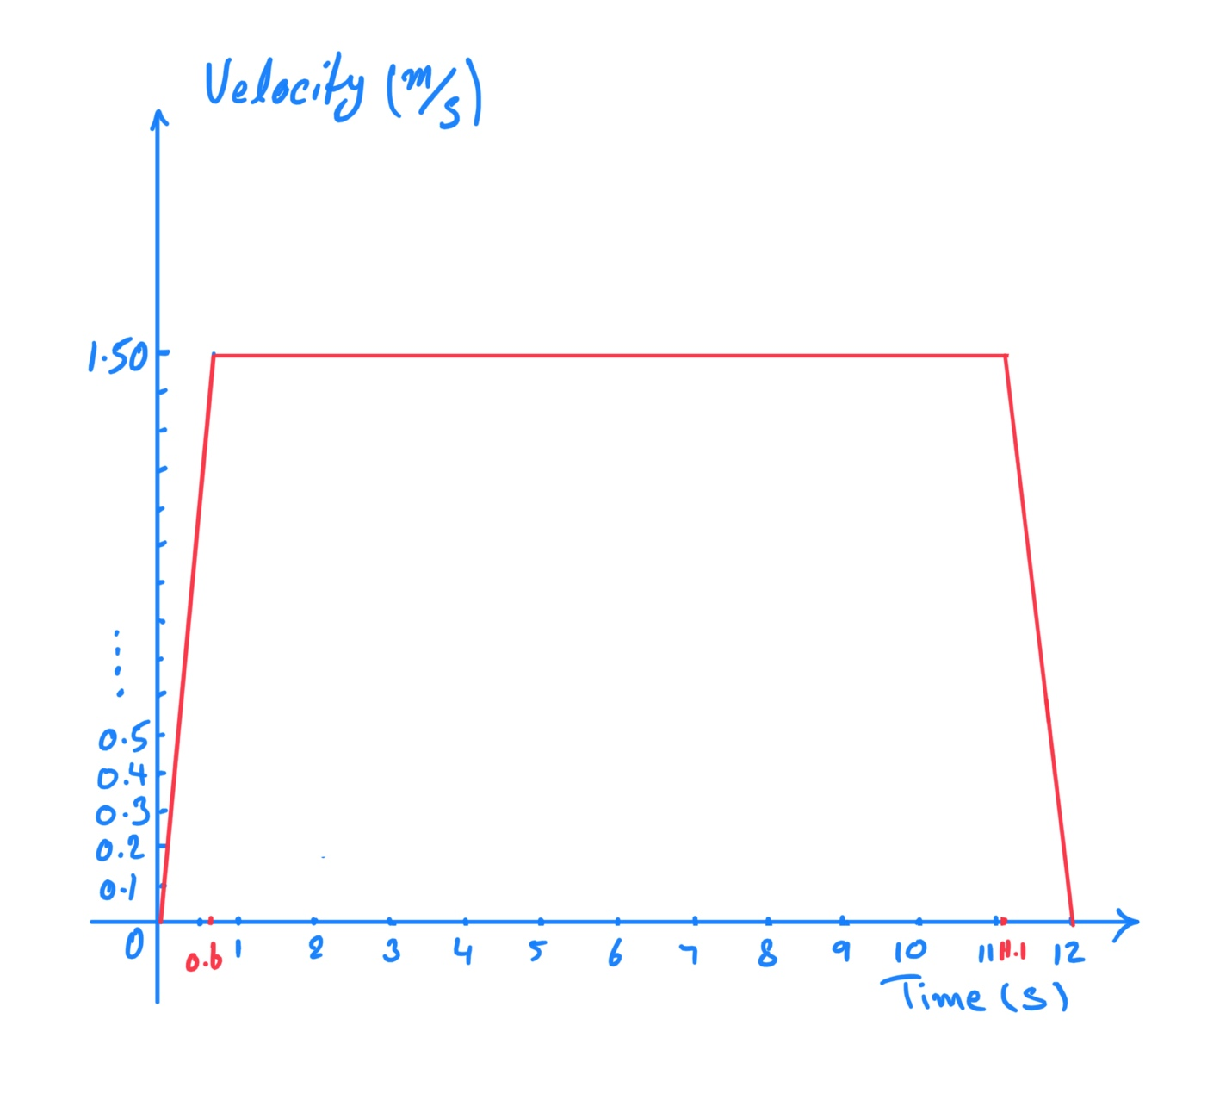
The mass of the elevator is 270 kg. Use the provided information to calculate
  - the acceleration of the elevator during the first 0.60 s.
  - the total distance travelled by the elevator.
  - the minimum work required to raise the elevator to the higher floor.
  - the minimum average power required to raise the elevator to the higher floor.
  - the efficiency of the electric motor that lifts the elevator, given that the input power to the motor is 7.0 kW.
  - On the graph, sketch a realistic variation of velocity for the elevator and explain your reasoning.

  - Look at the graph and analyze/describe the movement of the elevator during the 12 s.

  - Assume that the elevator now returns to the ground floor where it comes to rest. Describe and explain the energy changes during the whole up and down journey of the elevator.

